

SOFTWRAE DESIGN AND ARCHITECHURE

LAB ASSIGNMENT



**NAME : ALI BASHIR**----------------------------------------------------------------------------------------------------------------------------------------------------------------------------------------------------------  
**REG NO: FA22-BSE-007**

**SOCIAL NETWORKING –APPLICATION (LINKEDIN CLONE)  
  
  
USE CASE DIAGRAM  
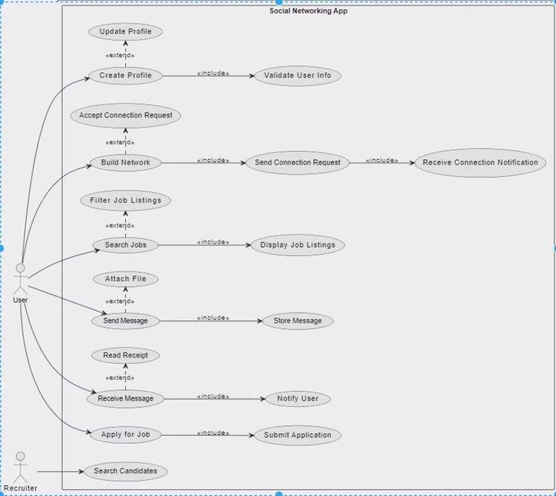  
  
  
  
  
  
  
  
FULLY DRESSED USECASE for "Create Profile"**

|  |  |
| --- | --- |
| **Use Case Name:** | Create Profile |
| **Primary Actor:** | User |
| **Stakeholders  and  Interests:** | • User: Wants to create an account to access the social networking platform.  • Admin: Needs to ensure user information is valid.  • Recruiter: May later interact with the user for job searches or offers. |
| **Preconditions:** | • User does not already have a registered profile. • User is on the registration page |
| **Post conditions:** | • The user account is created.  • User is notified of successful registration |
| **Main Success Scenario** | • User opens the social networking app and navigates to the "Create Profile" page.  • The system prompts the user to enter personal information (name, email, password, etc.).  • User enters valid details and submits the form.  • The system validates the input and checks if the email is already in use.  • If the details are valid, the system stores the user information and creates a new profile.  • The system notifies the user that their account has been successfully created.  • **User** is redirected to the homepage or login page. |
| **Trigger:** | The use case is triggered when the user selects the "Create Profile" option. |

**SYSTEM SEQUENCE DIAGRAM  
  
  
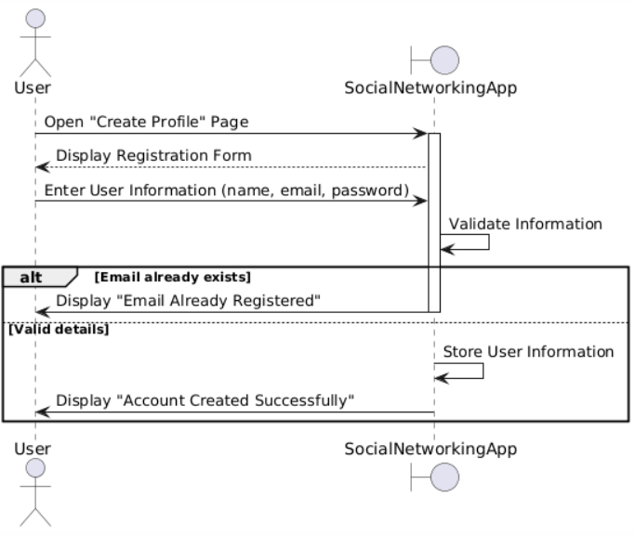**

**class diagram   
  
  
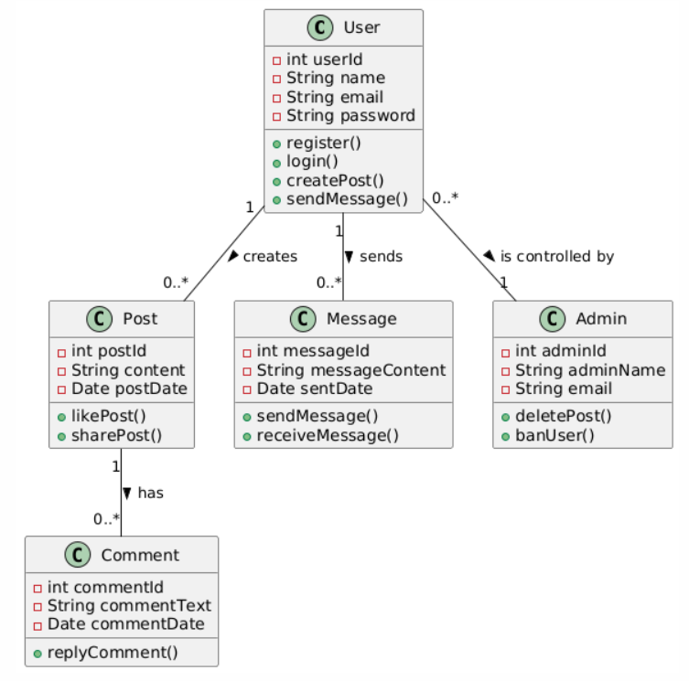  
  
  
  
communication diagram  
  
